Data visualization 2 Matthew Kurnia

3)

|  |  |
| --- | --- |
| Type of cheese | Categorical |
| Eye colour | Categorical |
| Class mark | Ordinal (A, B, C) or Quantitative (91, 73, etc.) |
| Tire pressure | Quantitative |
| ISBN number | Categorical |
| Unemployment rate | Quantitative |
| Starbucks drink sizes | Ordinal |
| Date an email newsletter was sent | Quantitative |
| Season-episode IDs of ‘The Crown’ | Categorical |
| Rankings of the top 10 movies on Netflix in UK | Quantitative |
| Fish species in Scottish Sea | Categorical |
| Weight classes of boxers | Ordinal |
| Model of an airplane | Categorical |
| Wingspan of bird | Quantitative |
| 100-metre race times | Quantitative |
| Personality of your cat | Categorical (shy, playful, sleepy) or Ordinal (naughty, neutral, nice) |

4)

Does income effect triglyceride levels? => compare trends

How much does age effect triglyceride levels? => discover distribution

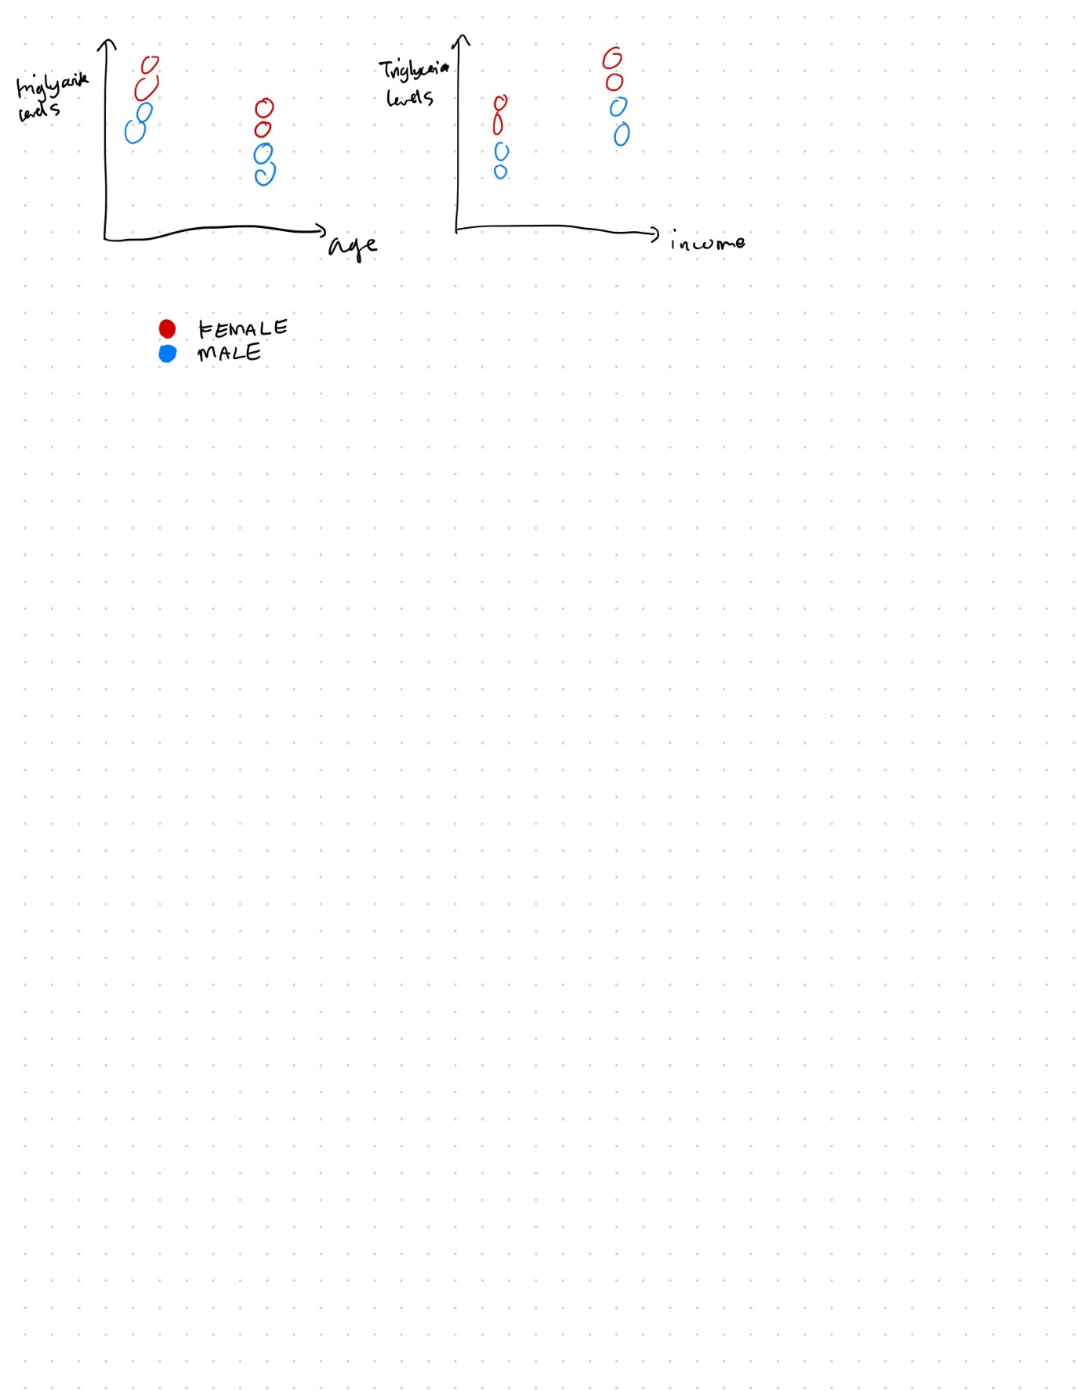

5)

1. The dataset can be seen as tabular, spatial, or networks.

The tabular view is immediate.

One can see it as spatial because we have information about the donor and recipient country, so we can draw this on the map. One can augment this map with a network, with there being a directed edge between one country to another to represent a donation.

#fields = 7

#data = 499

1. aiddata_id => categorical

year => quantitative

donor => categorical

recipient => categorical

commitment_amount_usd_constant => quantitative

coalesced_purpose_code => categorical

coalesced_purpose_name => categorical

#aiddata_id = 499

#donor = 25

#recipient = 129

#purpose_code = 127

#purpose_name = 135

max(year) = 2010

min(year) = 1991

max(amount) = 993865

min(amount) = 0.152847

1. A minimum amount of 0.152847 in usd is very low in terms of donations. This datapoint might be an outlier. We might need to filter out data points with amounts less than $10. Another thing might be that the number of purpose_code and purpose_name is different, so there may either be slight typos in the purpose_name, or duplicate purpose_codes.

Q1) Which countries has donated the most amount of money?

Q2) How does total donation amount trend across the years?

* Q1 doesn’t necessarily have to use a chart, but it will be useful to see how the countries compare in terms of donation amount. Perhaps a question that must have a chart is “How do the countries compare in terms of donation amount?”. Q2 would need a chart, because at a glance we cannot know whether the total donation amount is increasing or decreasing just by seeing the table.
* Discover trends/correlation (Q1)

Compare distribution (Q2)

* donor, commitment_amount_usd_constant (Q1)

year, commitment_amount_usd_constant (Q2)

* Assuming we don’t have any holes in the data, yes (up to 2010)
* Yes, for both Q1 and Q2, we need to sum the donation amounts of each country and year respectively.